**Mid Term Paper (Spring-2023)**

**BSCS (Morning)**

**Computer Networks ( CS-577 )**

**Maximum Marks: 18 Total Time: 1.0Hr**

**Note:** You can solve questions in any order but all parts should be together and to the point answers are required.

**Question N0. 1** *(2-3 lines Answer for each part)* **[Marks: 2+2]**

1. Differentiate between Baseband and Passband Signals
2. Name the sublayers of Data Link Layer and what are the responsibilities of each sublayer?

**Question N0. 2 [Marks: 2+1+1]**

If receiver B, receives the following original frame bits plus CRC check code bits: **101100110100**

and the divisor is **10011**, then:

1. Using CRC algorithm, find out that the data received is correct or not?
2. What are the actual data bits? *(1 line Answer)*
3. We have checksum at transport layer as well as at network layer then why CRC is required at Data Link Layer too? *(1-2 line Answer)*

**Question N0. 3 [Marks: 2+2]**

Suppose you have to store records of all outgoing packets of your network. In each record there are only 7 fields (Source IP, Destination IP, Source Port, Destination Port, Source MAC, Destination MAC and 2Byte Protocol field). On average network send 8,000 Packets per second and all IP addresses are IPv4 addresses.

1. Calculate storage requirement per second
2. Calculate storage requirement for One day

**Question N0. 4 [Marks: 3]**

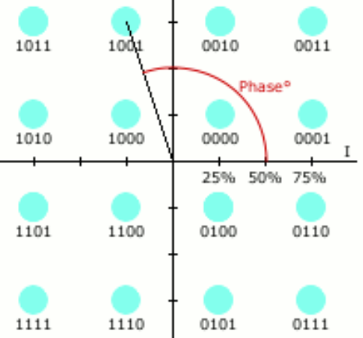Three characters (1 Byte each) has been received at receiver end. Using the following graph of 16-QAM, identify the characters, if received signals are:

**Amp Phase**

75% 225O

25% 135O

75% 135O

75% 45O

25% 315O

75% 135O

**Hint:**

248= “

179= |

75= K

65= A

**Question N0. 5 [Marks: 3]**

With reference to Selective Repeat Algorithm, Write the sender side algorithm, only for the event “Request to Send from Network layer”.

**\*\*\*\*Good Luck\*\*\*\*\***